READ CAREFULLY – Failure to follow these instruction could result in loosing every signature that you spent time collecting.
1) If your printing the packet at home, make sure its assembled correctly. Look at page number on bottom page 1 of 8, 2 of 8, 3 of 8, etc.
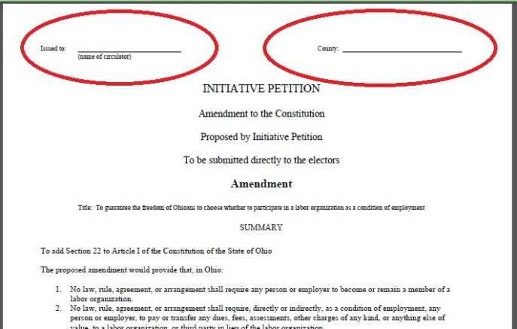
2) ISSUED TO - The circulator MUST enter their name on the first page, upper left corner before any signatures are collected. This person must witness all signatures in this packet. Do NOT allow anyone to sign a packet until your name is on the top of the form.
3) COUNTY – Enter County name upper right corner, Packet should contain signatures from ONLY this county, Start another packet if someone from another county wants to sign. One county per packet.
4) Signature Blocks – The person signing MUST be an Ohio Registered Voter. Their signature, address, should be where they registered to vote. YES, You can register people to vote and they can then sign the packet.. Four items to watch for;
a) If a gross error is made, draw a line thru the entire block, upper left corner to lower right corner. DO NOT OBLITERATE IT, just one obvious line. Have person start over again in next block.
b) “Date of Signing” must be in order. Be careful when flipping pages or starting a new day.
c) “Ohio County” – People will accidently put “Ohio”, not a big deal, put a small line thru it and have them put in the county. HINT: Point to that block and have them enter county first. REMEMBER – One county per packet, do not mix counties in the same packet.
d) Ward/Precinct. Leave it blank, even if they know it (most don’t know it)
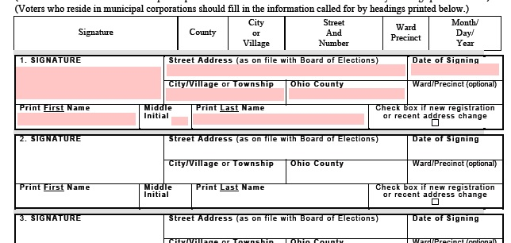

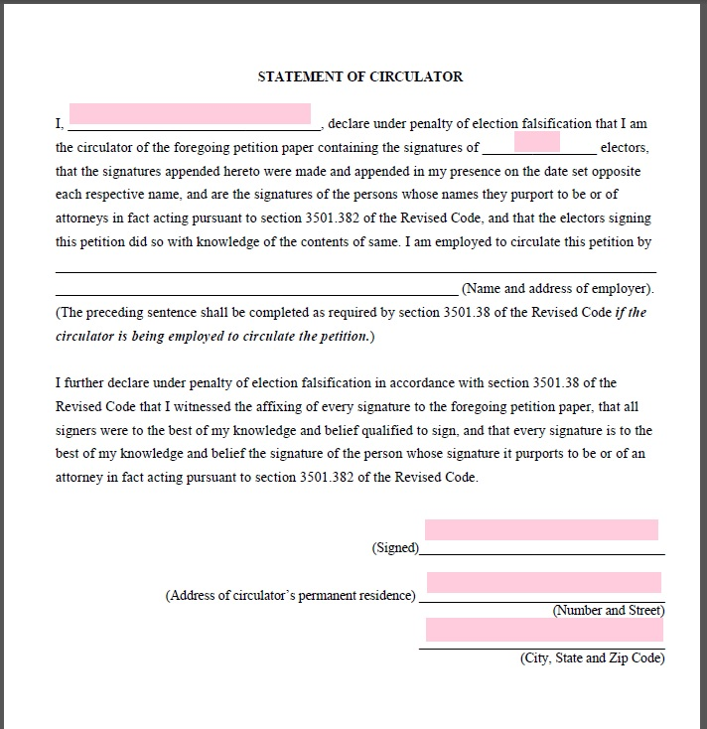
5) Statement of Circulator.
This is probably the most important page in the packet. A simple mistake on this page can render all the signatures invalid.
The person signing this page is stating they have witnessed all the signatures in this packet.
NO CORRECTIONS, no cross outs, no whiteout, etc. If an error is made, replace the back page with a new one. I always keep a couple spare back pages.
“I ___, declare” >> The name MUST match the name on the front cover.
“signatures of ___electors” >> This is the total number of valid signatures in the packet. Count all valid signature blocks. If a signature block is blank or has been crossed out, it does not count. If a signature page was accidently skipped . i.e. accidently skipped page 4 of 8, (common with the packets that are printed on both sides) Cross out the entire page.
Place a big “N/A” in the Employed by section. You are a volunteer circulator.
You must sign, include your address city, state, zip
When you turn in your packets, your Coordinator will do a quick review of your packets checking for errors. The time to fix errors is now, not trying to mail packets back, or loosing signatures because of a silly mistake.

